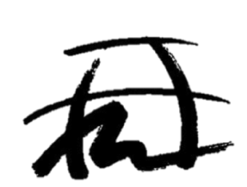

JAPAN-AMERICA SOCIETY OF SOUTHERN COLOARDO
SPONSORSHIP REGISTRATION FORM

The Japan-America Society of Southern Colorado is a 501(c)(3) non-profit organization and we provide educational and cultural organization promoting increased awareness, education, and understanding between the citizens of Southern Colorado and Japan.
Sponsorship Information
Please print company name as you would like it to appear on printed material:

Company Name: ____________________________________________________________

Contact Name: ______________________________________________________________

Address/City/State/Zip Code: ___________________________________________________

Email: ______________________________________________________________________
Sponsorship Levels:
- Gold Sponsor gets one fore-some and company sign in every players golf cart.
- Beverage sponsor gets one fore-some and your company sign on the beverage cart
- Hole sponsor get company sign on a tee box
- Note: We supply all signs for all sponsorship levels
Please check sponsorship level:
_____ $650 Gold sponsor _______ $500 Beverage Cart Sponsor ________ $120 Hole Sponsor
_____ other dollar amount as mentioned at luncheon
Additional sponsorship or questions can be emailed to JASSC.info@gmail.com

